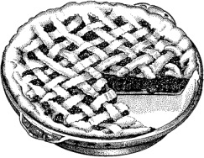
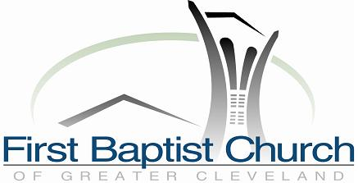
Waitress
Movie and Pie Fundraiser
To Benefit Cleveland’s
Domestic Violence Center
Committed to a comprehensive approach to ending domestic violence and fostering peaceful relationships.

Pie-Baking Contest! - Raffle! - Pie-Eating Contest!
Friday, October 9 7:30pm $8 donation
First Baptist Church 3630 Fairmount Blvd, Shaker Hts
www.AdamWhiting.com/Waitress

Waitress
Movie and Pie Fundraiser
To Benefit Cleveland’s
Domestic Violence Center
Committed to a comprehensive approach to ending domestic violence and fostering peaceful relationships.

Pie-Baking Contest! - Raffle! - Pie-Eating Contest!
Friday, October 9 7:30pm $8 donation
First Baptist Church 3630 Fairmount Blvd, Shaker Hts
www.AdamWhiting.com/Waitress
Waitress
Movie and Pie Fundraiser
To Benefit Cleveland’s
Domestic Violence Center
Committed to a comprehensive approach to ending domestic violence and fostering peaceful relationships.

Pie-Baking Contest! - Raffle! - Pie-Eating Contest!
Friday, October 9 7:30pm $8 donation
First Baptist Church 3630 Fairmount Blvd, Shaker Hts
www.AdamWhiting.com/Waitress

Waitress
Movie and Pie Fundraiser
To Benefit Cleveland’s
Domestic Violence Center
Committed to a comprehensive approach to ending domestic violence and fostering peaceful relationships.

Pie-Baking Contest! - Raffle! - Pie-Eating Contest!
Friday, October 9 7:30pm $8 donation
First Baptist Church 3630 Fairmount Blvd, Shaker Hts
www.AdamWhiting.com/Waitress

