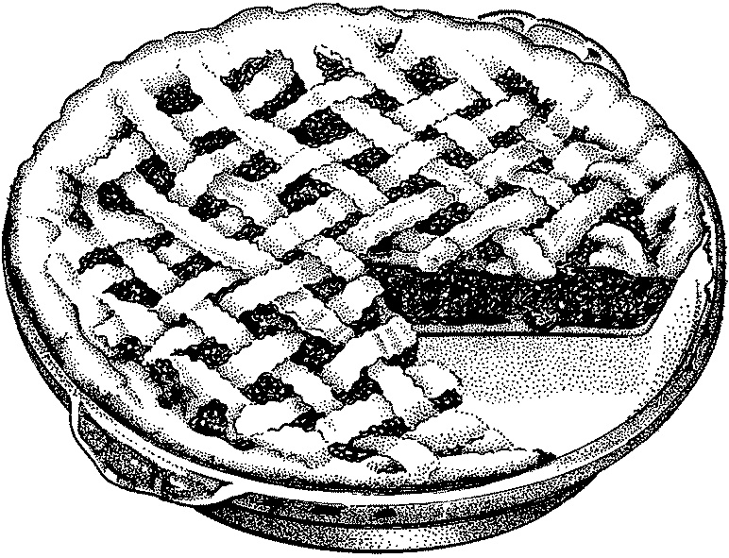
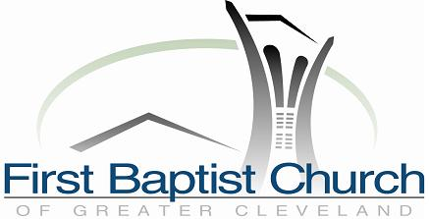
Waitress
Movie and Pie Fundraiser
To Benefit Cleveland’s
Domestic Violence Center
Committed to a comprehensive approach to
ending domestic violence and
fostering peaceful relationships.

Pie-Baking Contest!
Pie Sampling! Pie-Eating Contest!
Raffle!

Friday, October 9 7:30pm $8 donation
First Baptist Church 3630 Fairmount Blvd, Shaker Hts
www.AdamWhiting.com/Waitress

