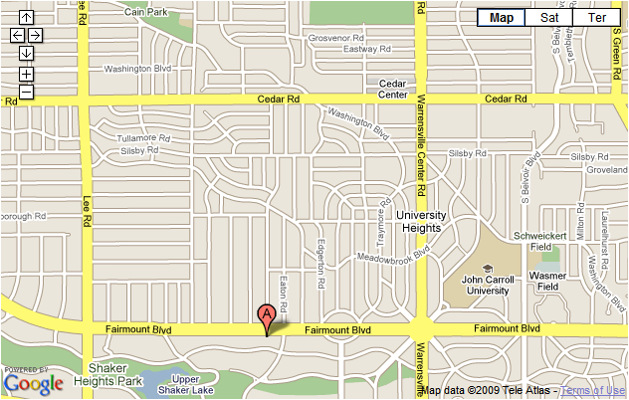
Waitress Movie and Pie Fundraiser -- Friday, October 9 7:30pm
First Baptist Church -- 3630 Fairmount Blvd, Shaker Hts

Waitress Movie and Pie Fundraiser -- Friday, October 9 7:30pm
First Baptist Church -- 3630 Fairmount Blvd, Shaker Hts

Waitress Movie and Pie Fundraiser -- Friday, October 9 7:30pm
First Baptist Church -- 3630 Fairmount Blvd, Shaker Hts

Waitress Movie and Pie Fundraiser -- Friday, October 9 7:30pm
First Baptist Church -- 3630 Fairmount Blvd, Shaker Hts

