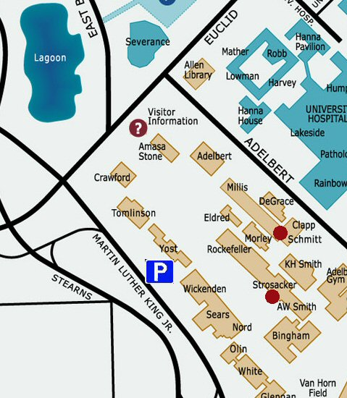

Charity Screening Firefly 12noon Schmitt
Sunday, October 1, 2006 Serenity 7pm Strosacker

Charity Screening Firefly 12noon Schmitt
Sunday, October 1, 2006 Serenity 7pm Strosacker

Charity Screening Firefly 12noon Schmitt
Sunday, October 1, 2006 Serenity 7pm Strosacker

Charity Screening Firefly 12noon Schmitt
Sunday, October 1, 2006 Serenity 7pm Strosacker

