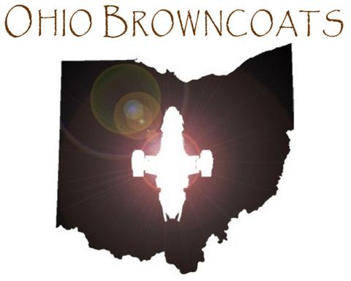
Friday, February 24, 2006
7:00pm, 9:30pm, 12:00midnight
Strosacker Auditorium -- $3 admission
Free parking: MLK, just south of Euclid
Case Western Reserve University Campus

RAFFLE!! COSTUME CONTEST!!
After each showing Between showings: 9:00pm, 11:30pm

PRIZES
Firefly and Serenity DVDs
Jayne’s hats
fan-designed T-shirts
official Serenity buttons and keychains
and more…

